**Top Shape Fitness Center**

Course：420-931-VA FRONT-END WEB PROGRAMMING section 05807

StudentID：2201546

StudentName：Jianquan Liang

# Website display

### Home

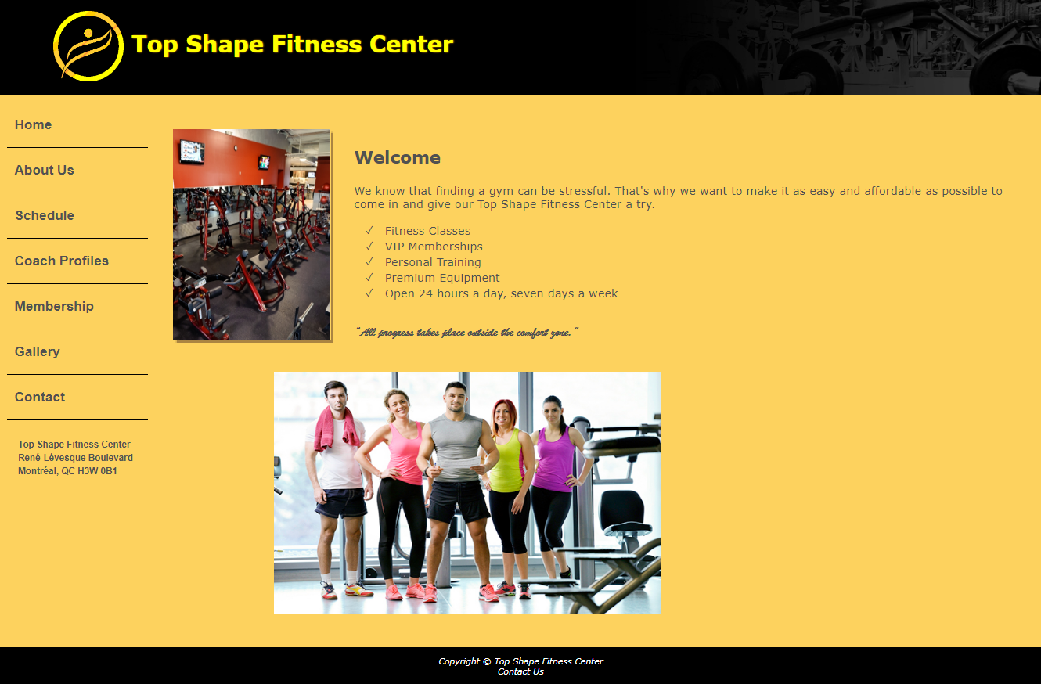

### **about us**

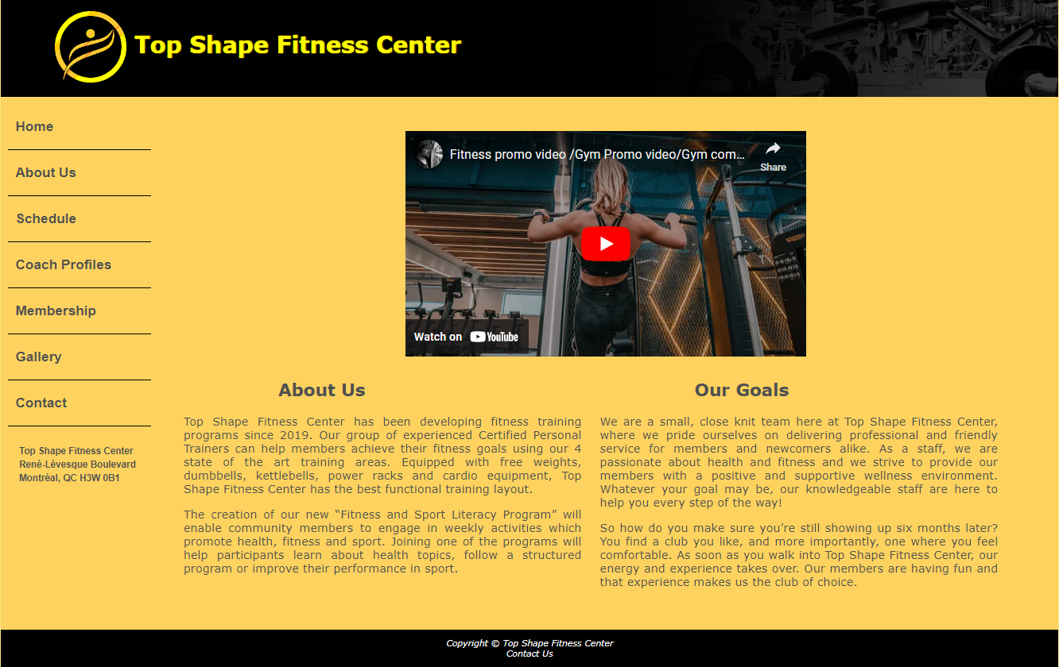

### **schedule**

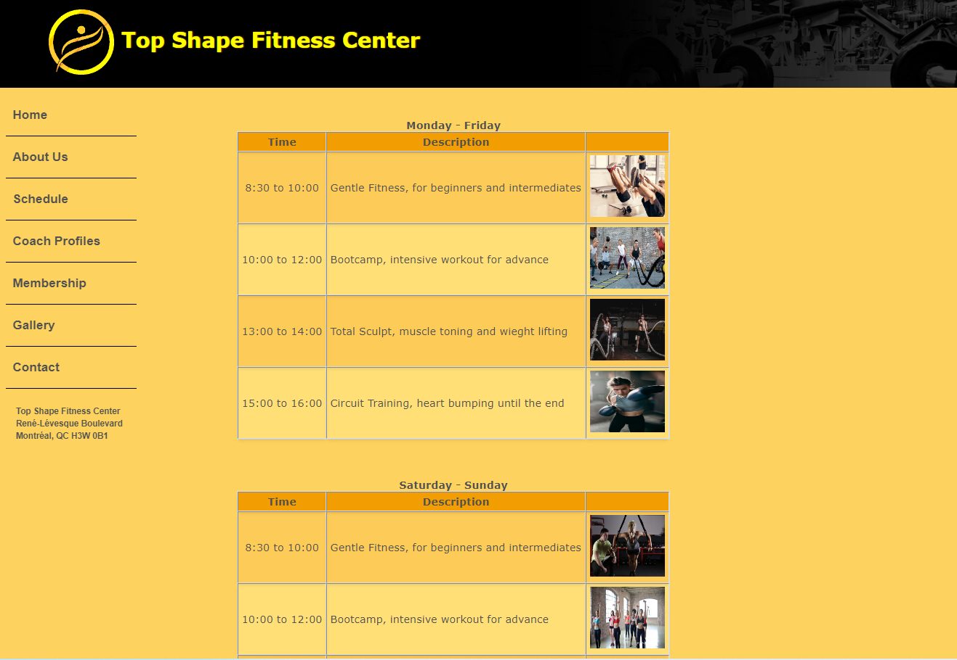

### **Coach profiles**



### **Gallery**

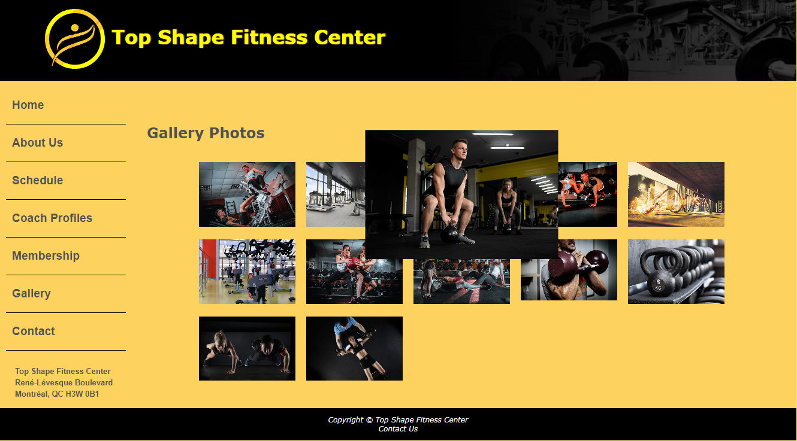

### **Contact**

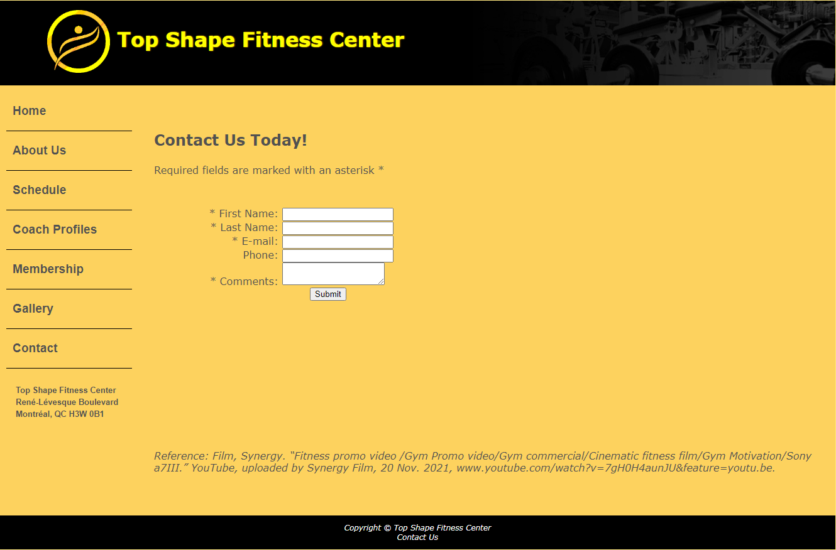

### **Membership**

